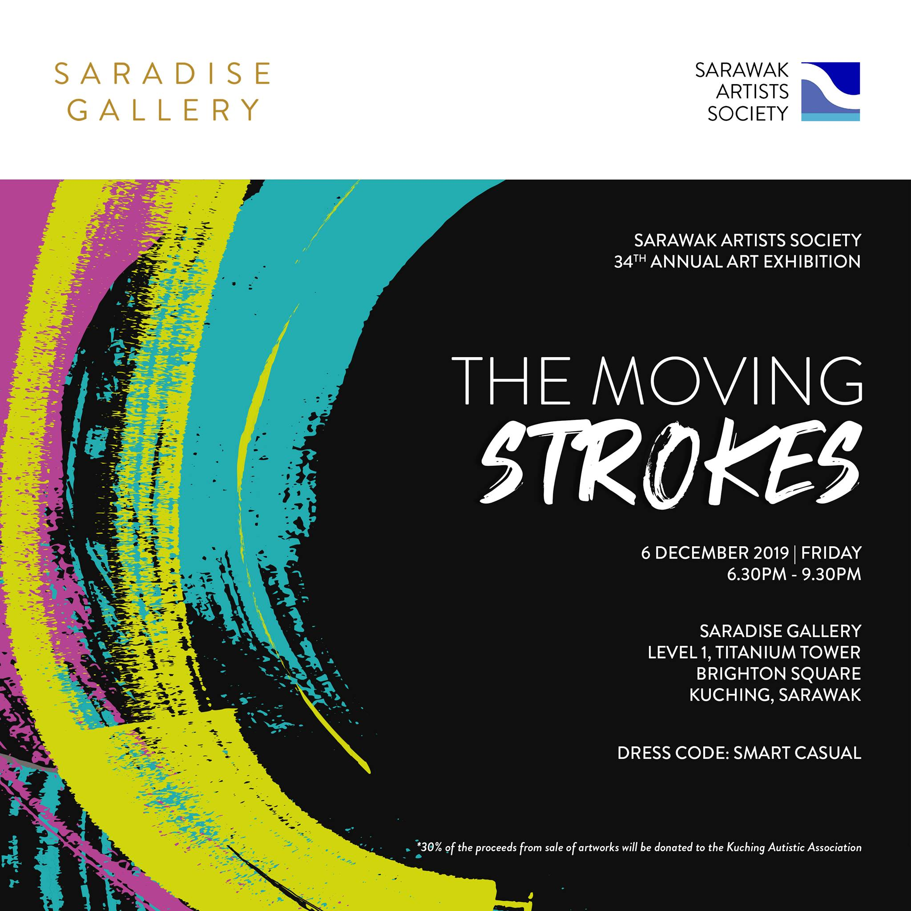

Exhibit one artwork:
Artist: Mohamad Faizuan Mat
Title: Trouble Spot I
Medium: Mix-media on canvas
Year: 2019

Description: Trouble Spot I, is a reaction on burning forest and the destruction made by human. Especially, it effected the wildlife and endangered animals. According to Al-Jazeera website (2019) that the Indonesian blazes are an annual problem, but this year are the worst since 2015 and have added to concerns about wildfire outbreaks worldwide exacerbating global warming. The smog is also affecting endangered animals like orangutans on Borneo, with dozens of the young apes at rescue centres contracting respiratory infections, according to the Borneo Orangutan Survival Foundation.

