40 art teachers to exhibit their work

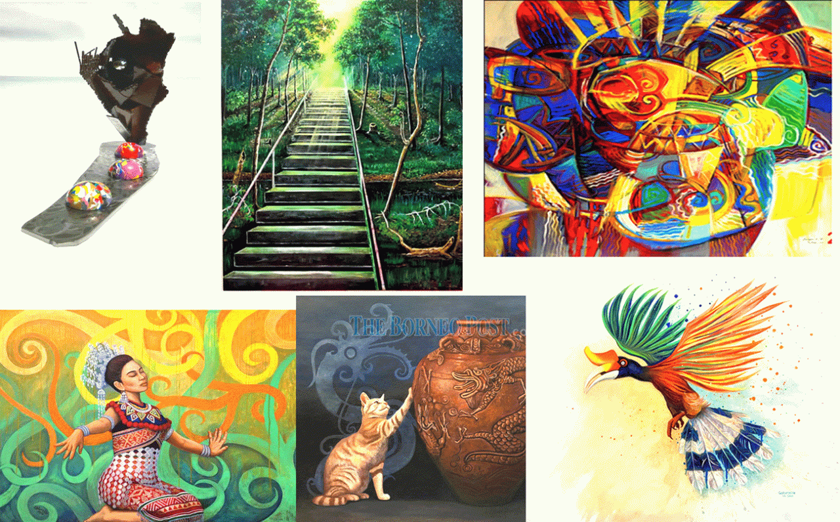

KUCHING: Artex (Art Teacher Exhibition) 2019 will be held at Galleria, Wesberly House from Friday (Nov 29) until Dec 28.
The visual art exhibition will feature the works of 40 art teachers, tutors, instructors, and lecturers from schools and tertiary institutes throughout Sarawak.
A press release said the artwork ranges from paintings to sculptures of all materials.
“Galleria hopes to promote art teachers and their works by showcasing their work to the people and tourists from all over the world,” said the press release.
“Galleria will continue to provide a venue to showcase visual arts.”
Among the artists involved are Melton Kais, John Bosco, Elvydiana, Wong Neng Lee, Leonard Darimi, Fresilia Ngee, Aliza Anthony Abet, Mohd Razif Mohd Rathi, Gabrielle Lim, Mohd Zamhari, Sylvester Jussem, Jerrery Jemi, Auzani Zeeda M Kassim, RH Hassan, Andriesse Ridu, Brendan Johnny, Ling Pik Kuong, Mohamad Ali, Fadzliyatun, and Florence.
Also exhibiting their work are Hamdani, Awangko Hamdan, Dr Yaakup, Faizuan, Damien Mpulop, Adam, Clement Jimel, Azrian Ali, Muhd Ruhaizat Rusli, Augustine Andrew Sammy, Mike Lawrence, Pete, Chieng Chong Ing, Roland Mapus, Mohamad Zamhari Abol Hassan, Baru Sigar, Zaidi El Masli, Azmeer Razali, and Wan Mohd Mazlan Yaacob.
All the artwork will be available for sale.
Artex is scheduled to be launched by Minister of Education, Science and Technological Research Dato Sri Michael Manyin Jawong on Friday (Nov 29) at 6pm.
It will be open to the public on weekdays from 8.30am to 5pm, and on Saturdays from 9am to noon throughout the exhibition period.
Galleria, Wesberly House is located on Lot 2812, Block 195, at Rubber Road West here.
For more information, call 016-886 5278.

