PAMERAN BAKAT MUDA SEZAMAN 2019
Di Balai Seni Negara
April – September 2019
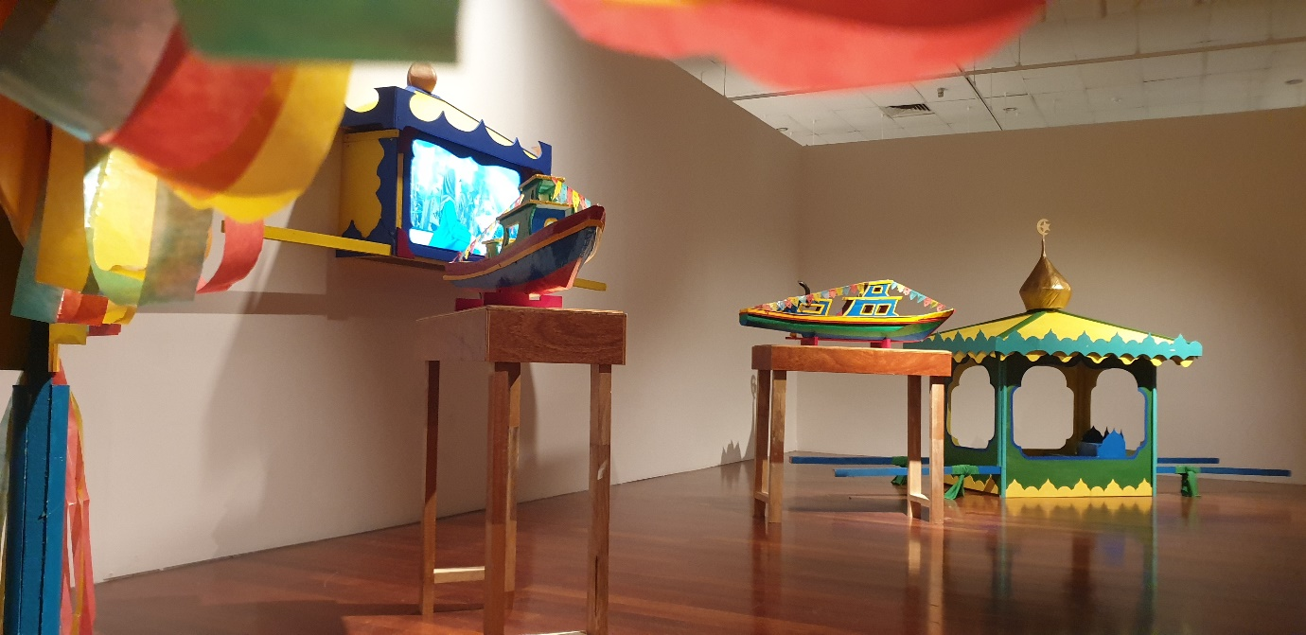
Tajuk Karya: The Parade of the Usungan
