‘State government backs private sector in raising city’s profile’
POSTED ON SEPTEMBER 9, 2019, MONDAY AT 12:09 AMNEWS, SARAWAK
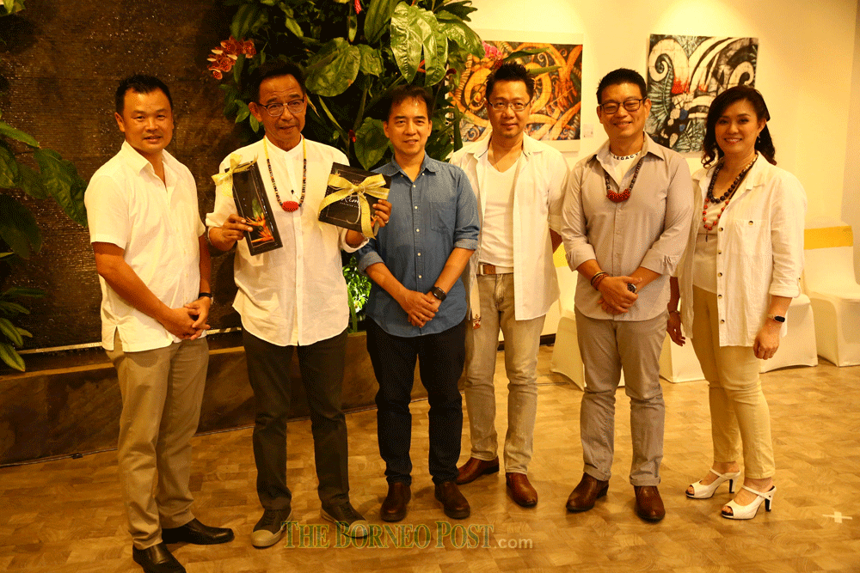
Abdul Karim (second left) holds a souvenir from Yee (left) at the event.
KUCHING: The state government is in support of the private sector holding various activities in making Kuching City a more attractive place.
Minister of Tourism, Arts and Culture Datuk Abdul Karim Rahman Hamzah, in saying this, added that Kuching has become an attraction for art enthusiasts.
“The state government is in full support as it is in line with making Kuching a more interesting city as many people, young and old, love art,” he said at the Rimba Fashion Exhibition at Saradise Gallery yesterday.
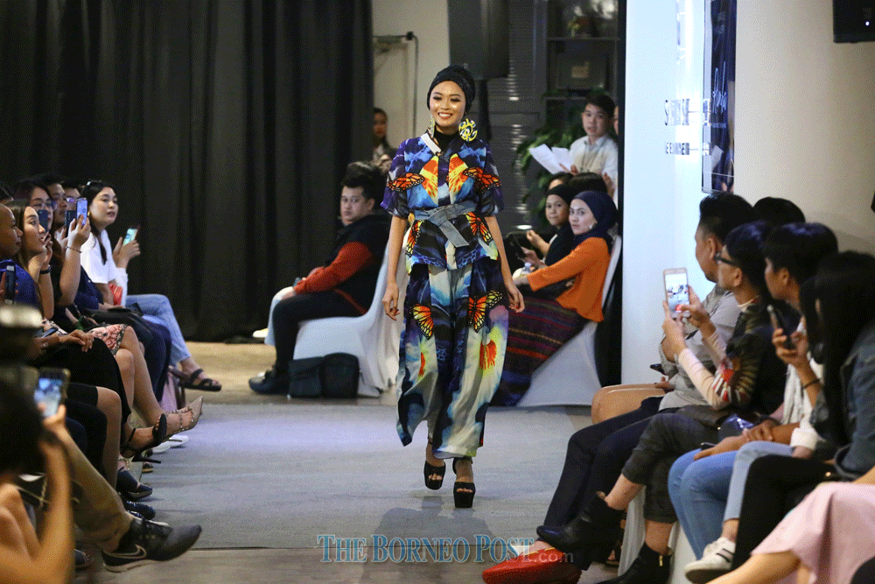
Among the designs paraded.
“It also becomes a platform for them to share ideas to make Kuching more interesting,” he added.
He informed that the state will hold the Spartan Race which is an extreme sport from the US that has been franchised, and targets 3,000 participations worldwide.
As of last week, there were 2,600 registrants and 60 per cent are international participants.
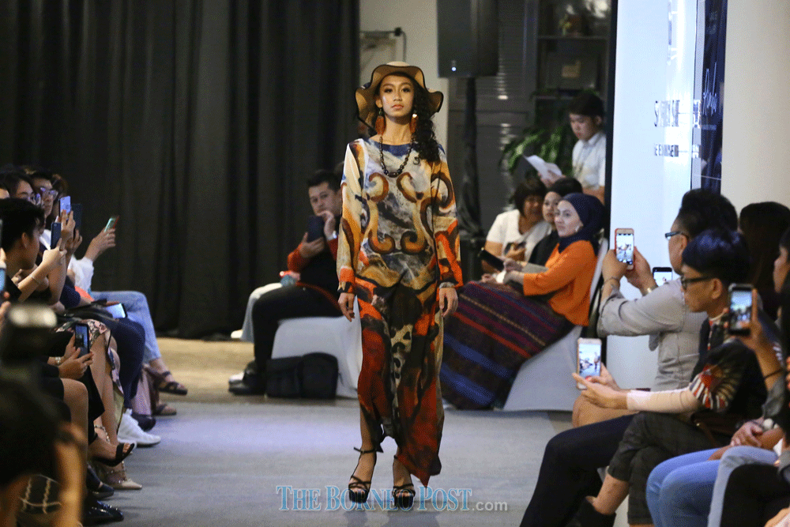
Among the designs paraded.
He added that the extreme sport has become a current lifestyle and the government supports the activity as it draws many participants from all over the world.
Additionally, hotel, homestay, restaurant and craft operators can generate additional income with the influx of visitors to Sarawak compared to last year, and at the same time propelling the state’s economy.
Meanwhile, Saradise Sdn Bhd chief operations officer Dylan Yee said the two-day exhibition that ended yesterday featured canvas painting to create unique clothing.
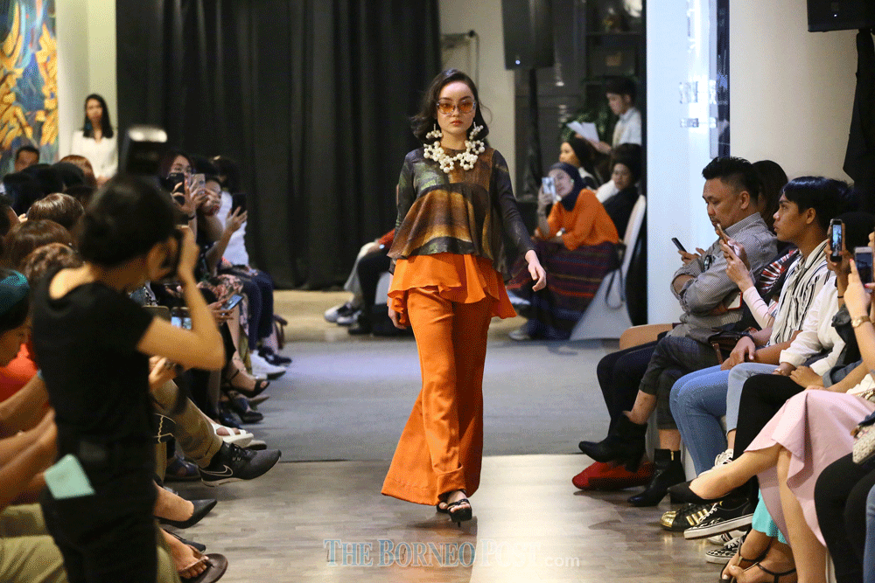
Among the designs paraded.
Among the artists involved were Sebastian Jong, Faizuan Mat, Norman Choo, Narong Daun, Angelina Bong, Gerald Goh, David Chew, Sylvester Jussem, Sheila Kho and Mary Ann Vaz.
Participating fashion designers were Dewi Khalid, Sonia Chong, Emil Hamlyn, Effie Jefferyson, Neng Kho Razali, Melissa Tiong, Azizah Razak, Antonia Isabelle, Steffi Debra, Danish Hakeem, Sasha Namara, Wini Coope, Hafiz Dressmaker, Rose Awing Belare and Aizat Rahman.
All of the designs were environment themed and presented on the catwalk by 30 local models.

